Animatronic skull build instructions

Parts:

The projects contains the following parts.

We recommend printing all parts in Brim, 100% scale, 20-30% infill and with Petg(PlA is also an option but you should use higher infill), keep in mind that you don’t want the parts the be too heavy since you’ll need stronger servos.

1\*B1: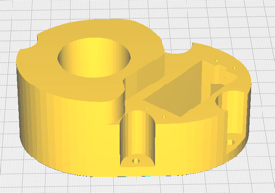 1\*N1: 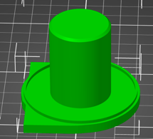 1\*N2: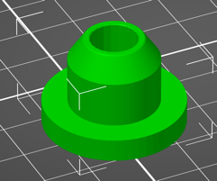

1\*N3: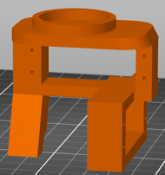 1\*N4: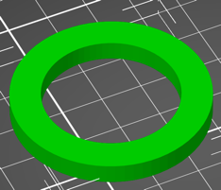 1\*N5: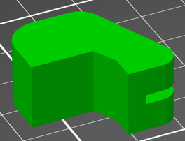

1\*F1: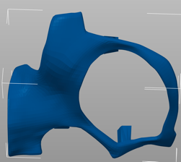 1\*F2: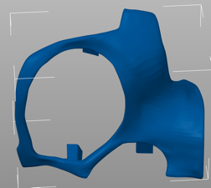 1\*F3: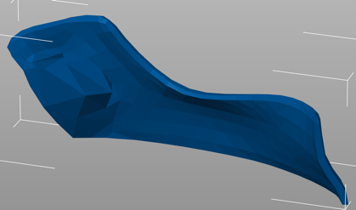

1\*F4: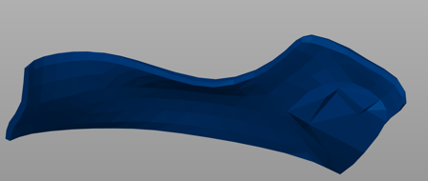 1\*J1: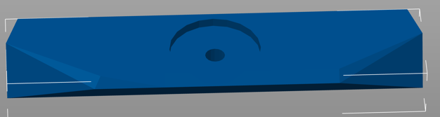

1\*J3: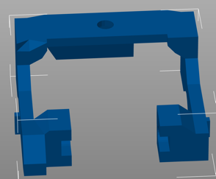

2\*J6: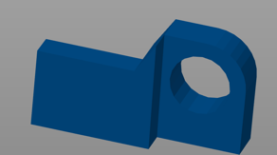

1\*J7: M1: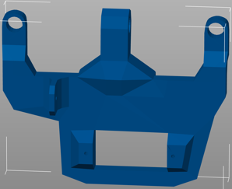 1\*M2: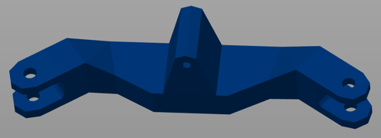

1\*M3: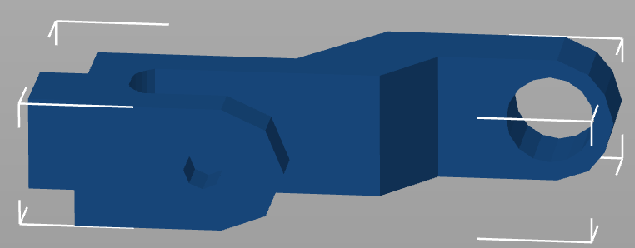 2\*M4: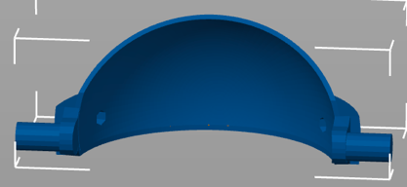

2\*M5: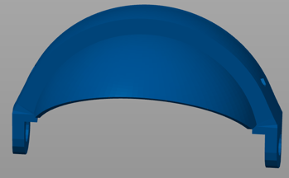 1\*S1: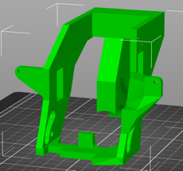 1\*S2: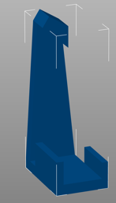

1\*S3: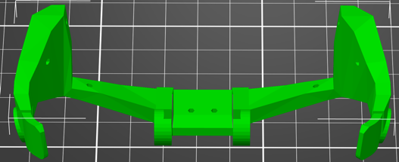 1\*S4: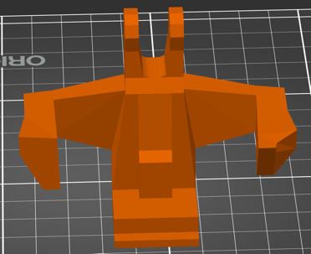

1\*T1: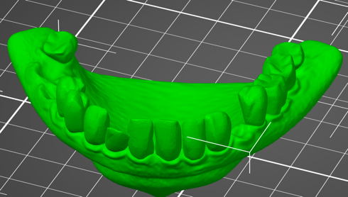 1\*T2: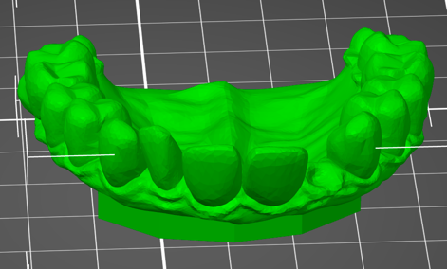

2\*E: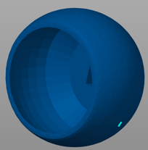 1\*RC: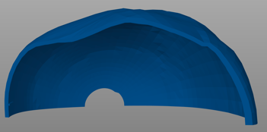 1\*RL: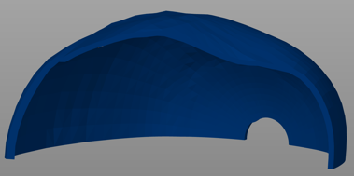

Tutorial:

1. Connect the M2 to both M3 using two m3 screws connector ( you may use hot glue to position the screw connector inside the M2 so there will be minimum loose)

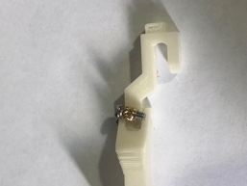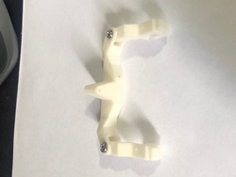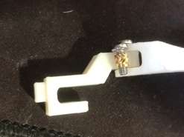

1. Connect M2 and M3 to the M1 using the same screw conector,

* the hook on the M1 suppose to be directed down.
* Use the same screw connector and two m3 screws

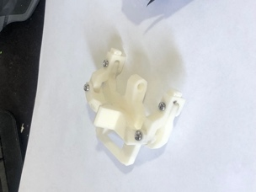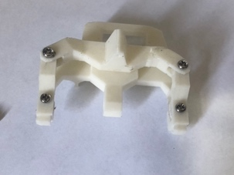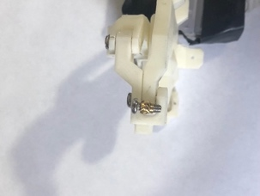

1. Using two m3 screws and 2 scrwes connectors connect M1 to S4, screws head should be in the outer side of S4

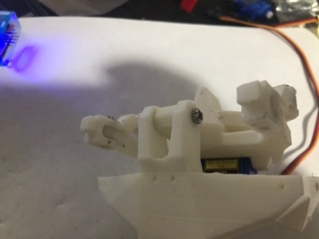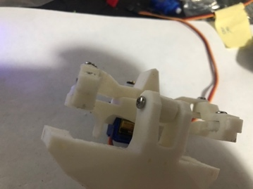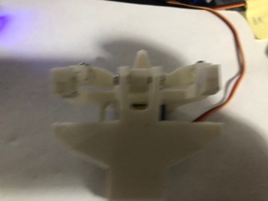…………………….

1. Connect one mini servo to the M1, servo hand should be assemble from the left size, plug one pushed stoper to the servo and connect one hook to it , the hook should be inserted into the small hole in the M1 part
2. 